**A**

**PROJECT REPORT**

**ON**

**“Optician Management System”**

**WITH REFERENCE TO**

**“RANJAN OPTICIAN”**

**Submitted By**

**Mr. Akshay Ashok Dongare**

TO

**SHIVAJI UNIVERSITY KOLHAPUR**

FOR THE AWARD OF

**B.C.S. (Computer Science)  
UNDER THE GUIDANCE OF**

**Prof. Miss M.R.Nadavadekar (M.S.C. Computer)**

**THROUGH**

**Prof.Dr.Kotmire S.Y. (M.Sc., Ph.D.)  
THE PRINCIpAL  
 SHIVRAJ COLLEGE OF ARTS, COMMERCE AND D.S.KADAM SCIENCE COLLEGE,   
GADHINGLAJ.**

**2017-2018**

**K.V.R.S.S.S.**

**SHIVRAJ COLLEGE OF ARTS, COMMERCE &**

**D.S.KADAM SCIENCE COLLEGE, GADHINGLAJ**

**DIST. KOLHAPUR**



**CERTIFICATE**

This is to certify that the project entitled “**Optician Management System**” submitted by **Mr. Akshay Dongare**, to Shivaji University Kolhapur, in partial fulfillment of the degree of **B.C.S**, has been carried out under the guidance and supervision of Prof. M.R.Nadvadekar and the conclusion drawn by them during by them are based on work done and data collected by them during project work.

To the best of our knowledge and belief, the matter presented here has not been submitted earlier.

Date:

Place: Gadhinglaj

HOD EXAMINER PRINCIPAL

Prof. C.S.Nikam Prof. Dr. S.Y.Kotmire

**K.V.R.S.S.S.**

**SHIVRAJ COLLEGE OF ARTS, COMMERCE &**

**D.S.KADAM SCIENCE COLLEGE, GADHINGLAJ**

**DIST. KOLHAPUR**

**GUIDANCE CERTIFICATE**

This is to certify that the project entitled “Optician Management System” conducted at Shivraj College Gadhinglaj by Mr.Akshay A. Dongare.

In partial fulfillment of this work for award of Bachelor of Computer Science (B.C.S.) submitted to Shivaji University , Kolhapur has been completed under my supervision and guidance.

To the best of my knowledge and belief, the presented by them is original in nature and has not been from any source. In addition, this report has not been submitted earlier for ant degree or diploma of Shivaji University or any other university.

Place : Gadhinglaj.

date :

Prof.M.R.Nadavadekar

(M.C.A.)

(Project Guidance)

**DECLARATION**

We undersigned here by declare that this report entitled “**Optician Management System**” for Shivraj Arts, Commerce and D.S. Kadam Science college , Gadhinglaj is our original work prepared under guidance of Prof. C.S.Nikam the Empirical finding in this report are based on data collected by us . The matter presented is this report is not copied from any source.

We understand the such copy is liable for punishment in any way the university Authorities deem to fit. This work has not been submitted to either Shivaji University or any other University.

This work is humbly submitted to Shivaji University ,Kolhapur for the award of the degree of Bachelor of Computer Science (B.C.S.)

Date :

Place : Gadhinglaj

Mr. Akshay Dongare

**ACKNOWLEDGEMENT**

It gives great pleasure to remain deeply indebted to our guide prof Nikam C.S. for providing us with the required facilities for the academic achievement . under whom we had the privilege to work. The faith and Confidence shown by him in us boosted our moral and motivated us to perform better in preferring this project.

We are thankful to those who have contributed either directly or indirectly to this project.

Thanking You.

Mr. Akshay Dongare

**INDEX**

* **Introduction to project**
* **Organization Profile**
* **Introduction**
* **Existing System**
* **Need & Scope of System**
* **Proposed System**
* **System Diagrams**
* **Objectives**
* **Requirements engineering**
  + **Requirements Gathering**
  + **SRS**
* **System Design**
* **DFD**
* **ERD**
* **System Requirement**
* **Hardware Requirement**
* **Software Requirement**
* **Database Design**
* **Input (Form) Design**
* **Coding**
* **Reports**
* **Conclusion**
* **Bibliography**

**INTRODUCTION**

**Organization Profile**

|  |  |
| --- | --- |
| **Organization Name :** | **Ranjan Opticians** |
| **Owner :** | **Rahul kode** |
| **Mobile Number :** | **9421206706** |
| **Year of Establishment :** | **1982** |
| **Area of Work :** | **Gadhinglaj** |

**Introduction**

This software for Optician Management implements capabilities of computer to maintain the work information of optician. Using this software user can easily manage the information of patient and dispense and also can also manage appointments with patients. Software provide efficient user interface to user so that user can easily handle the application.

It is required great effort to manage the records manually. If we want to find any record of patient then it is very time consuming in case of manual system but, using software we can quickly find the information of patient from thousands of patient’s records.

Software can generate reports monthly or year wise which is very useful for user to take overview of work. This Software helps opticians to view reports as required and whenever required also it gives guaranty that information provided will be very accurate and correct as computer makes less mistakes than human.

**1.3 Existing System**

* The present System is maintained manually and involves many registers if some previous records have to be found then all the registers have to be searched until the required is found.
* Existing manual system partly work on registers and ledgers work. Here each record is written manually and consumes lot of time.
* All the calculations are done manually so the error rate is high.
* Validation, deletion, updating of any record is done manually**.**

**1.4 Need & Scope of System**

* Existing system is completely depending on manual work. This is information store in registers.
* In existing system more man power is required.
* This information store in register is not accurate as well as there is various mistakes in data fill process of system.
* To storage large amount of data, more stationary is required which increases the cost of stationary.
* In existing system lots of time is spend on information in register and managing mistakes and not accuracy of the records.
* The existing system, any authorized system can access the register so, security is provide in existing system.
* In existing system we cannot modify the record also we cannot keep backup of document.
* The management cannot be effectively followed by existing system.
* To overcome this disadvantages software is required.

**1.4.2 Scope of System**

* This application software plays important role in work of opticians.
* It maintains information of patient and dispense records .
* It maintains information of patient when patient first comes to optician.
* It maintains check up information of patient after check up by opticians.
* It can provide facility to maintain appointments of optician.
* It maintains sales records and dispense records.

**Proposed System**

Proposed system software keep track of opticians working .It can maintains information of patient when patient first come to Optician .Then it provide facility to give appointment to patient for Eye check up. It can store information of check up after check up of patient by opticians. After check we can take order form patient .this software can create invoice of order and maintain information of invoices. It is also able to generate prescription after check up and recipient after delivery of product which can be print or save on drive.

System Diagrams

2.1 Objective of System

* To develop the complete computerized application that can satisfy all the needs of optician.
* To get more reliable and efficient maintenance of work of optician.
* To get security and updating data energy and authorization.
* To care of update of software.
* To get sufficient information of each patient.
* To manage the information about the patient , check up and dispense by paperless work.
* To provide security and authenticity and to save valuable time of optician.

Requirement Engineering

2.2.1. Requirement gathering

Information of this software is collecting by visiting to optician and arranging interview with optician . Software requirements are specified directly as per opticians demands and requirements. And by observing of system and working.

2.2.2. SRS (Software Requirements Specification)

A]Functional Requirements

* + Software created should be able to store information of every patient and should return information whenever needed .
  + It should store information of patient when patient visit first time to optician.
  + It should provide manage opticians appointments.
  + It should provide the information of patient having appointments and pending eye check up.
  + It should store information of check up.
  + It should generate prescription after check up.
  + It should show history of patient treated and their check up information.
  + It should provide facility to find patient history from stored information.
  + It should maintain information of dispense.
  + It should store information of orders taken.
  + It should provide way to find sales history.
  + It should generate recipient after delivery.

B] Non-Functional Requirements

* Software should be reliable and should work correctly.
* It should provide proper user interface to user.
* Software should provide proper security and authorization to user.

Entity Relationship Diagram

Data Flow Diagram

0th level DFD

1st level DFD

2nd level DFD for 2nd process

2nd level DFD for 3rd process

System Requirements

Software Requirements

* Netbeans 8.1 .
* My-SQL Workbench 6.3 CE
* Web Browser ( FireFox )
* Glassfish / WAMPP/XAMPP Server

Hardware Requirements

* + Intel dual core or above
  + Ram 1.0GB or Above
  + Minimum 20Gb or Above

About Java

Java Is an [**object-oriented programming**](http://www.freejavaguide.com/object_oriented_programming.html) language developed by James Gosling and colleagues at Sun Microsystems in the early 1990s. Unlike conventional languages which are generally designed either to be compiled to native (machine) code, or to be interpreted from source code at runtime, Java is intended to be compiled to a byte code, which is then run (generally using JIT compilation) by a [**Java Virtual Machine**](http://www.freejavaguide.com/virtual_machine.html)**.**

Java was started as a project called "Oak" by James Gosling in June 1991. Gosling's goals were to implement a virtual machine and a language that had a familiar C-like notation but with greater uniformity and simplicity than C or C++. The first public implementation was Java 1.0 in 1995. It made the promise of "Write Once, Run Anywhere", with free runtimes on popular platforms. It was fairly secure and its security was configurable, allowing for network and file access to be limited. The major web browsers soon incorporated it into their standard configurations in a secure "[applet](http://www.freejavaguide.com/java_applet.html)" configuration popular quickly. New versions for large and small platforms (J2EE and J2ME) soon were designed with the advent of "Java 2". Sun has not announced any plans for a "Java 3".

**Goals of Java Language -**

1. It should use the [**object-oriented programming**](http://www.freejavaguide.com/object_oriented_programming.html) methodology.
2. It should allow the same program to be executed on multiple operating systems.
3. It should contain built-in support for using computer networks.
4. It should be designed to execute code from remote sources securely.
5. It should be easy to use by selecting what was considered the good parts of other object-oriented languages.

**Advantages of Java –**

* Java is easy to learn.   
  Java was designed to be easy to use and is therefore easy to write, compile, debug, and learn than other programming languages.
* Java is object-oriented.   
  This allows you to create modular programs and reusable code.
* Java is platform-independent.

One of the most significant advantages of Java is its ability to move easily from one computer system to another. The ability to run the same program on many different systems is crucial to World Wide Web software, and Java succeeds at this by being platform-independent at both the source and binary levels.

* Java is distributed.  
  Java is designed to make distributed computing easy with the networking capability that is inherently integrated into it. Writing network programs in Java is like sending and receiving data to and from a file.
* Java is secure.  
  Java considers security as part of its design. The Java language, compiler, interpreter, and runtime environment were each developed with security in mind.
* Java is robust.  
  Robust means reliability. Java puts a lot of emphasis on early checking for possible errors, as Java compilers are able to detect many problems that would first show up during execution time in other languages.

Java is Multithreaded is the capability for a program to perform several tasks simultaneously within a program. In Java, multithreaded programming has been smoothly integrated into it, while in other languages, operating system-specific procedures have to be called in order to enable multithreading.

**Java NetBeans IDE 8.1**

The Net Beans Platform is a framework for simplifying the development of Java Swing desktop applications. The Net Beans IDE bundle for Java SE contains what is needed to start developing Net Beans plugins and Net Beans Platform based applications no additional JDK is required.

Applications can install modules dynamically. Any application can include the Update Centre module to allow users of the application to download digitally signed upgrades and new features directly into the running application. Reinstalling an upgrade or a new release does not force users to download the entire application again.

The platform offers reusable services common to desktop applications, allowing developers to focus on the logic specific to their application. Among the features of the platform are.

Net Beans IDE is an open-source integrated development environment. Net Beans IDE supports development of all Java application types (Java SE (including Java FX), Java ME, web, EJB and mobile applications) out of the box. Among other features are an Ant-based project system, Maven support, refactoring, version control (supporting CVS, Subversion, Mercurial and Clear case).

All the functions of the IDE are provided by modules. Each module provides a well-defined function, such as support for the Java language, editing, or support for the CVS versioning system, and SVN. Net Beans contains all the modules needed for Java development in a single download, allowing the user to start working immediately. Modules also allow Net Beans to be extended. New features, such as support for other programming languages, can be added by installing additional modules. For instance, Sun Studio, Sun Java Studio Enterprise, and Sun Java Studio Creator from Sun Microsystems are all based on the Net Beans IDE.

**WHAT IS DATABSASE**

A database is a separate application that stores a collection of data . Each database has one or more distinct Application for creating , accessing managing , searching and replicating the data it holds.

Other kinds of data stores can be used such as files on the file system or large hash tables in memory but data fetching and writing would not be fast and easy with those types of systems .

So now a days we use relational database management systems (RDBMS) TO store and manage huge volume of data . This is called relational database because all the data is stored into different bales and relations are established using primary keys or other keys known as foreign keys.

A RELATIONAL DATABASE MANAGEMENT SYSTEM(RDMS)

* Enables you to implement a database with tables , columns and indexes .
* Guarantees the Referential Integrity between rows of various tables .
* Updates the indexes automatically .
* Interprets an my sql query and combines information from various tables.

**My SQL DATABASE**

MySQL is a leading open source database management system . It is a multi-user, multithreaded database management system. MySQL is especially popular on the web It is one of the parts of the very popular LAMP platform. Linux Apache , MySQL and PHP MySQL database is available on most important OS platforms . It run on BSD Unix, Linux , Windows or Mac. Wikipedia, You tube ,Facebook use MySQL. These sites manage millions of queries each day .MySQL server software and the client libraries are dual-licensed GPL version 2 and proprietary license.

The development of MySQL begun in 1994 by a Swedish company MySQl AB in 2008 Sun was bought by oracle in 2010.

MySQl PostgreSQL , Firebird ,SQLite, Derby and HSQLDB are the most well known open source database systems.

**MySQL Workbench 6.3**

**MySQL Workbench** is a visual [database design](https://en.wikipedia.org/wiki/Database_design) tool that integrates [SQL](https://en.wikipedia.org/wiki/SQL) [development](https://en.wikipedia.org/wiki/Software_development), [administration](https://en.wikipedia.org/wiki/Database_administration_and_automation), [database design](https://en.wikipedia.org/wiki/Database_design), creation and maintenance into a single [integrated development environment](https://en.wikipedia.org/wiki/Integrated_development_environment) for the [MySQL](https://en.wikipedia.org/wiki/MySQL) database system. It is the successor to DB Designer 4 from fabFORCE.net, and replaces the previous package of software, [MySQL GUI Tools Bundle](https://en.wikipedia.org/wiki/MySQL_Workbench#MySQL_GUI_Tools_Bundle).

On March 5, 2015, the MySQL Workbench Team announced its first public beta release of Version 6.3. The first general-availability release was made on April 23, 2015. New features include a "fast migration" option to migrate the data from the command-line instead of the GUI, a SSL certificate generator, improved SQL auto-completion, a new table data import and export wizard, and MySQL Enterprise Firewall support. Up to version 6.3.8, MySQL Workbench for MacOS has incompatibilities with MacOS Sierra.

**Fetures**

* General
  + Database Connection & Instance Management
  + Fully scriptable with [Python](https://en.wikipedia.org/wiki/Python_(programming_language)) and [Lua](https://en.wikipedia.org/wiki/Lua_(programming_language))
  + Support for custom plugin.
  + Supports MySQL Enterprise features (Audit Log, Firewall, and Enterprise Backup)
* SQL Editor
  + Schema object browsing, inspection, and search
  + SQL syntax highlighter and statement parser
  + SQL code completion and context sensitive help
  + Multiple and editable result sets
  + Visual EXPLAIN
  + Unicode support

What is JSP

**JavaServer Pages** (JSP) is a technology for developing Webpages that supports dynamic

content. This helps developers insert java code in HTML pages by making use of special JSP tags, most of which start with **<%** and end with **%>**.

A JavaServer Pages component is a type of Java servlet that is designed to fulfill the role of a user interface for a Java web application. Web developers write JSPs as text files that combine HTML or XHTML code, XML elements, and embedded JSP actions and commands.

Using JSP, you can collect input from users through Webpage forms, present records from a database or another source, and create Webpages dynamically.

JSP tags can be used for a variety of purposes, such as retrieving information from a database or registering user preferences, accessing JavaBeans components, passing control between pages, and sharing information between requests, pages etc.

DATABASE DESIGN

Users

|  |  |  |  |  |  |
| --- | --- | --- | --- | --- | --- |
| Field | Type | Null | Key | Default | Extra |
| Id | int(11) | NO | PRI |  | auto_increment |
| full_name | char(30) | YES |  |  |  |
| Dob | Date | YES |  |  |  |
| Gender | char(7) | YES |  |  |  |
| Address | varchar(40) | YES |  |  |  |
| contact_number | bigint(20) | YES |  |  |  |
| e_mail | varchar(30) | YES |  |  |  |
| user_name | varchar(30) | YES |  |  |  |
| password | varchar(30) | YES |  |  |  |

Patient

|  |  |  |  |  |  |
| --- | --- | --- | --- | --- | --- |
| Field | Type | Null | Key | Default | Extra |
| Id | int(11) | NO | PRI |  | auto_increment |
| Name | char(30) | YES |  |  |  |
| Dob | Date | YES |  |  |  |
| Gender | char(7) | YES |  |  |  |
| Address | varchar(40) | YES |  |  |  |
| contact_no | bigint(11) | YES |  |  |  |
| e_mail | varchar(30) | YES |  |  |  |
| Arrival | varchar(20) | YES |  |  |  |
| user_name | varchar(30) | YES |  |  |  |
| Checked | tinyint(1) | YES |  | 0 |  |

Checkup_info

|  |  |  |  |  |  |
| --- | --- | --- | --- | --- | --- |
| Field | Type | Null | Key | Default | Extra |
| id | int(11) | NO | PRI |  | auto_increment |
| patient_name | char(30) | YES |  |  |  |
| patient_id | varchar(20) | YES |  |  |  |
| dob | Date | YES |  |  |  |
| gender | char(6) | YES |  |  |  |
| address | varchar(50) | YES |  |  |  |
| contact_no | bigint(11) | YES |  |  |  |
| e_mail | varchar(30) | YES |  |  |  |
| arrival_date | Date | YES |  |  |  |
| RE_D_SPH | float(5,2) | YES |  |  |  |
| RE_D_CYL | float(5,2) | YES |  |  |  |
| RE_N_SPH | float(5,2) | YES |  |  |  |
| RE_N_CYL | float(5,2) | YES |  |  |  |
| LE_D_AXIS | float(5,2) | YES |  |  |  |
| LE_D_VA | float(5,2) | YES |  |  |  |
| LE_N_AXIS | float(5,2) | YES |  |  |  |
| LE_N_VA | float(5,2) | YES |  |  |  |
| checkup_date | Date | YES |  |  |  |
| optician | char(30) | YES |  |  |  |

Prescriptions

|  |  |  |  |  |  |
| --- | --- | --- | --- | --- | --- |
| Field | Type | Null | Key | Default | Extra |
| id | int(11) | NO | PRI |  | auto_increment |
| p_id | int(11) | YES |  |  |  |
| const_use | tinyint(1) | YES |  |  |  |
| near_work | tinyint(1) | YES |  |  |  |
| distance | tinyint(1) | YES |  |  |  |
| bifocal | varchar(30) | YES |  |  |  |
| shade | varchar(30) | YES |  |  |  |
| instructions | varchar(100) | YES |  |  |  |
| cdate | Date | YES |  |  |  |

Invoices

|  |  |  |  |  |  |
| --- | --- | --- | --- | --- | --- |
| Field | Type | Null | Key | Default | Extra |
| id | int(11) | NO | PRI |  | auto_increment |
| name | char(30) | YES |  |  |  |
| contact_no | bigint(11) | YES |  |  |  |
| frame_type | varchar(30) | YES |  |  |  |
| frame_price | float(8,2) | YES |  |  |  |
| lens_type | varchar(30) | YES |  |  |  |
| lens_price | float(8,2) | YES |  |  |  |
| solution_price | float(6,2) | YES |  |  |  |
| price | float(10,2) | YES |  |  |  |
| advance | float(10,2) | YES |  |  |  |
| created | Date | YES |  |  |  |
| delivered | Date | YES |  |  |  |
| username | char(30) | YES |  |  |  |
| deliverded | tinyint(1) | YES |  | 0 |  |
| delivereded | Blob | YES |  |  |  |

Connected Users

|  |  |  |  |  |  |
| --- | --- | --- | --- | --- | --- |
| Field | Type | Null | Key | Default | Extra |
| user_name | varchar(30) | YES |  |  |  |
| user_password | varchar(30) | YES |  |  |  |
| session_id | varchar(100) | YES |  |  |  |

INPUT DESIGN

(FORM DESIGN)

LogIn

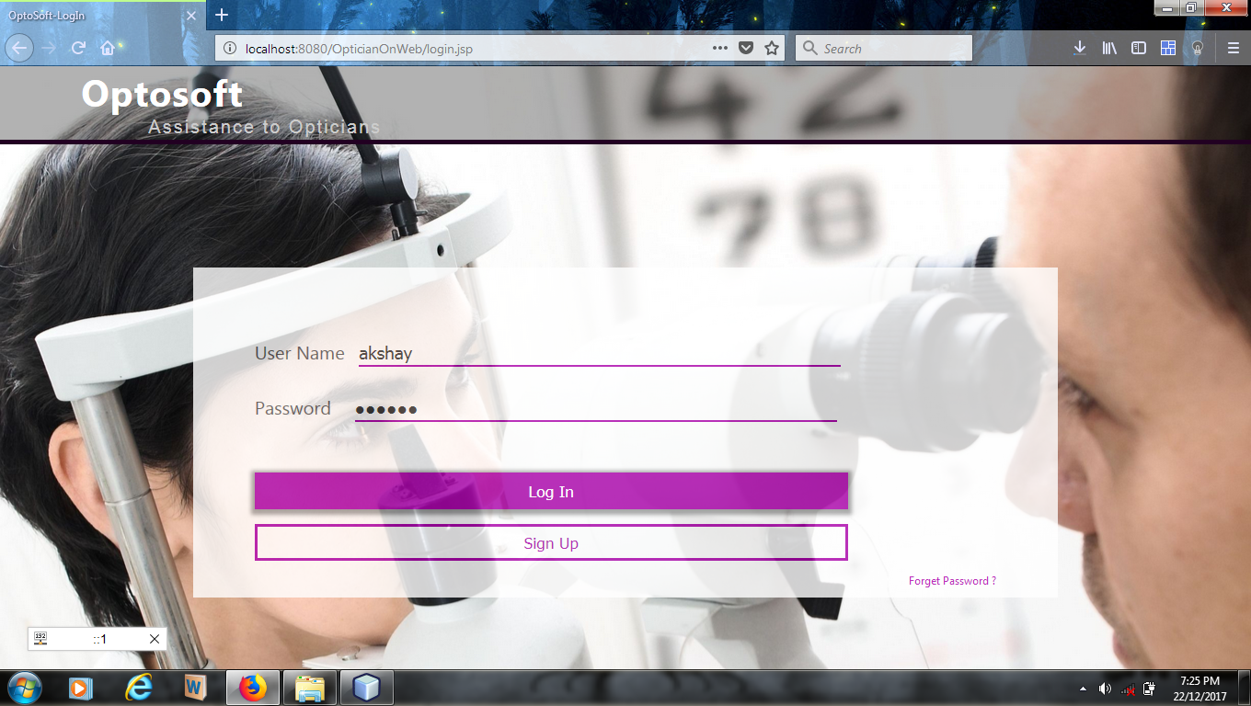

Sign Up

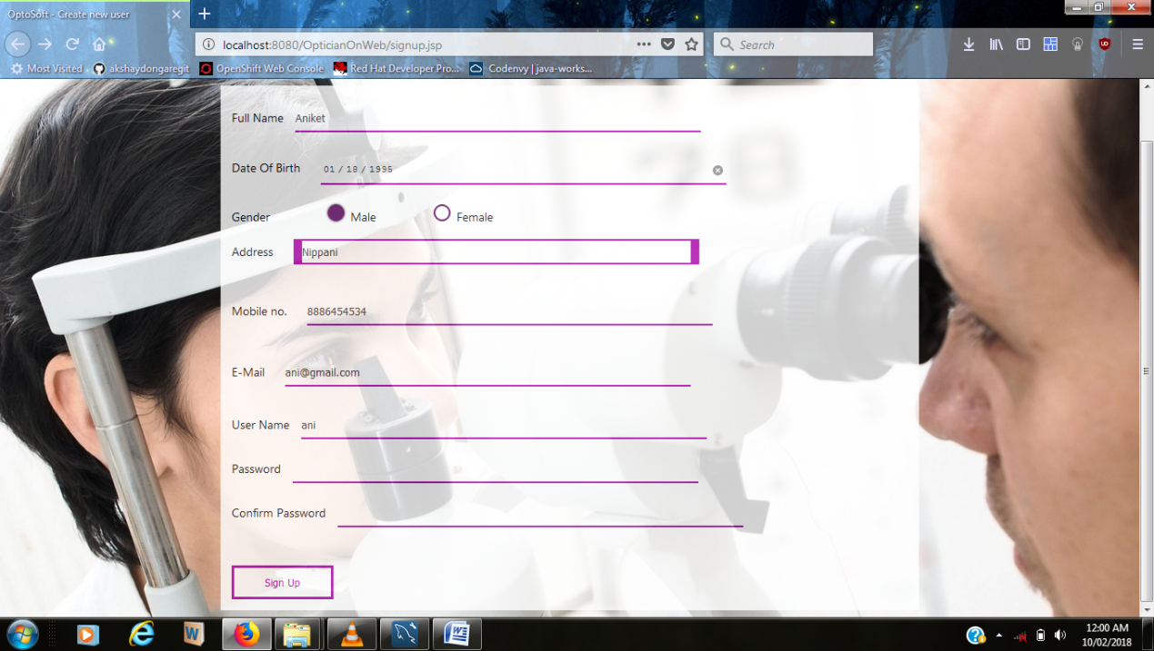

Home

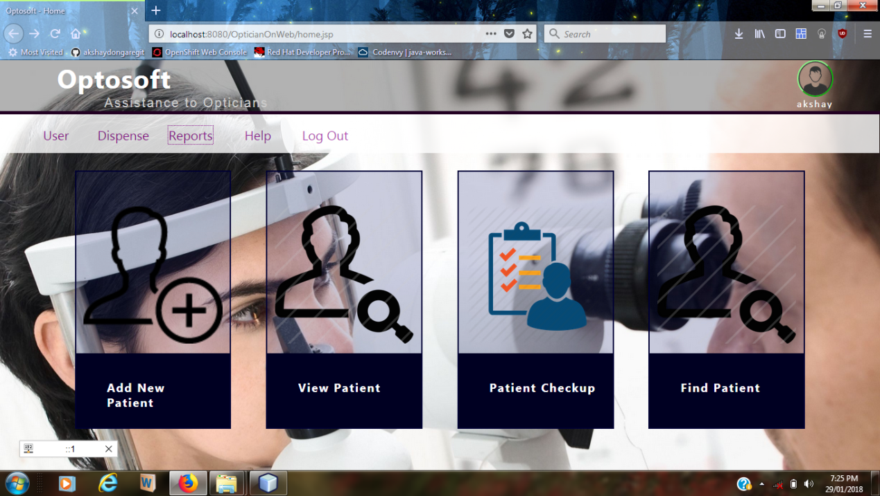

Add Patient

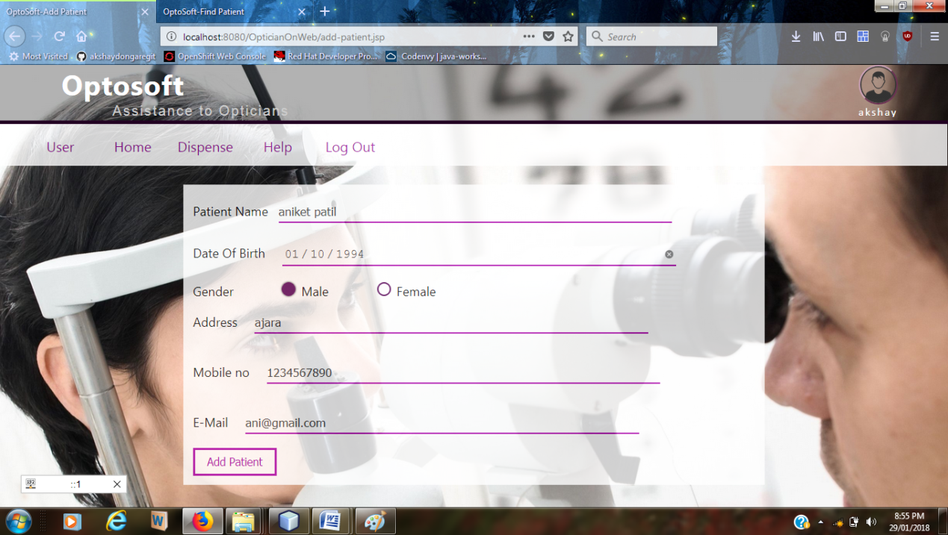

View Patient

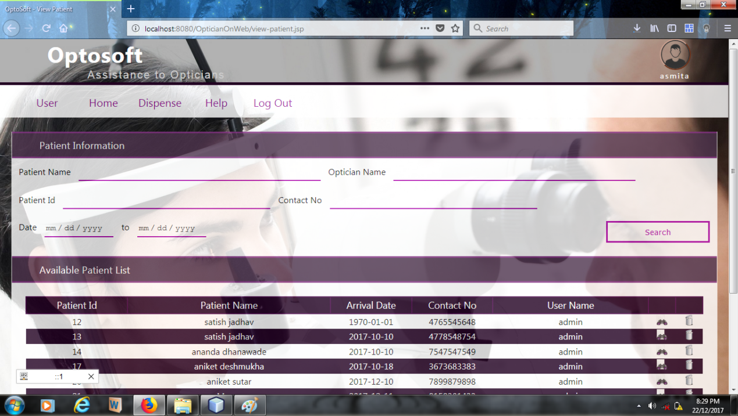

Edit Patient

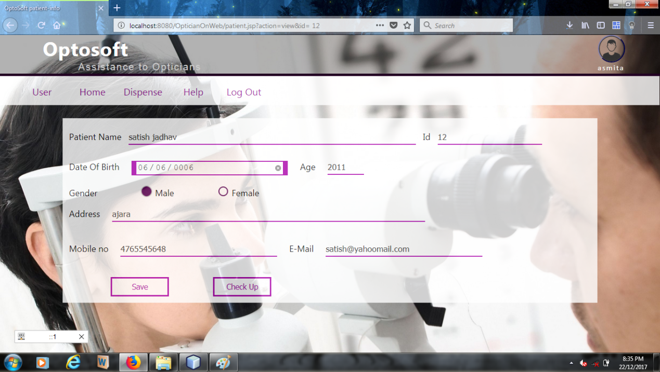

Patient Check-up

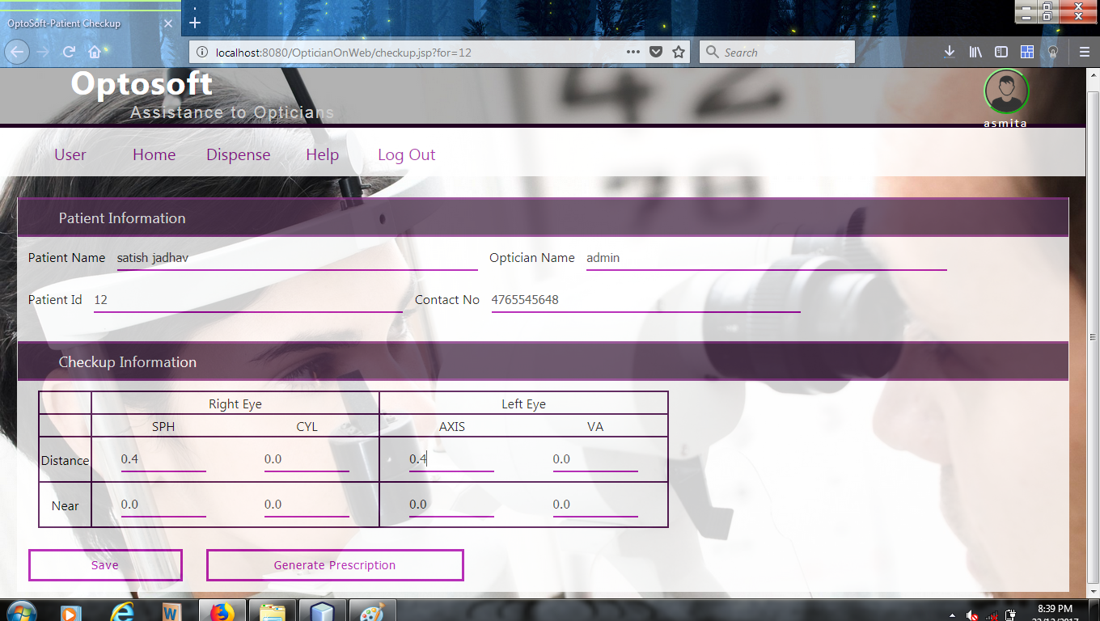

Prescription

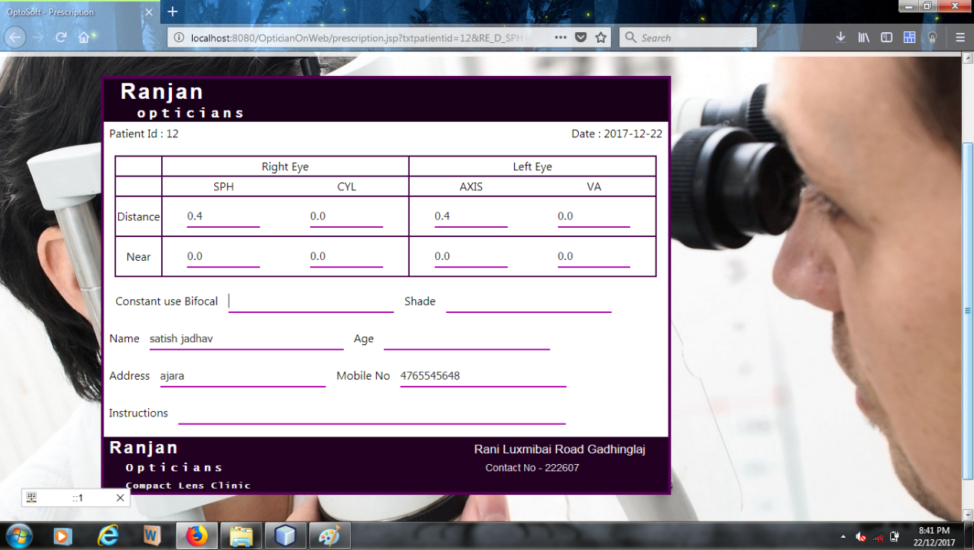

Find Patient

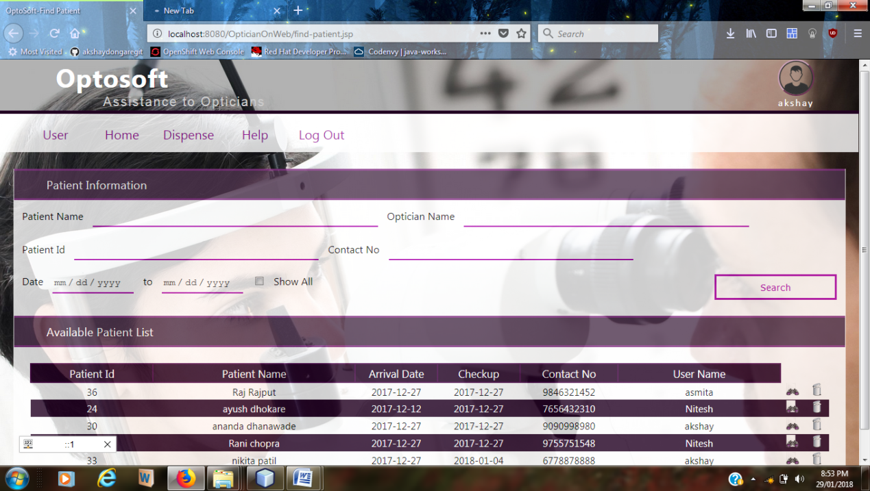

Dispense

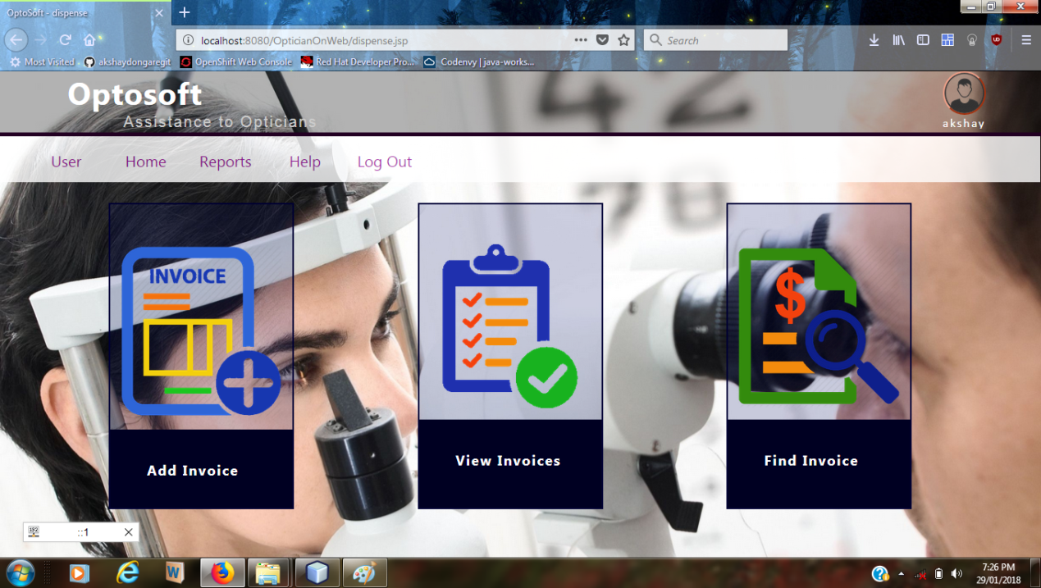

Add Invoice

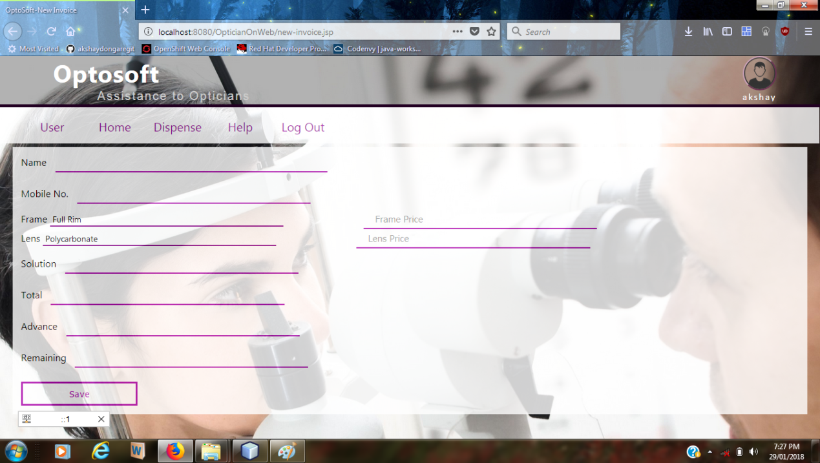

View Invoice

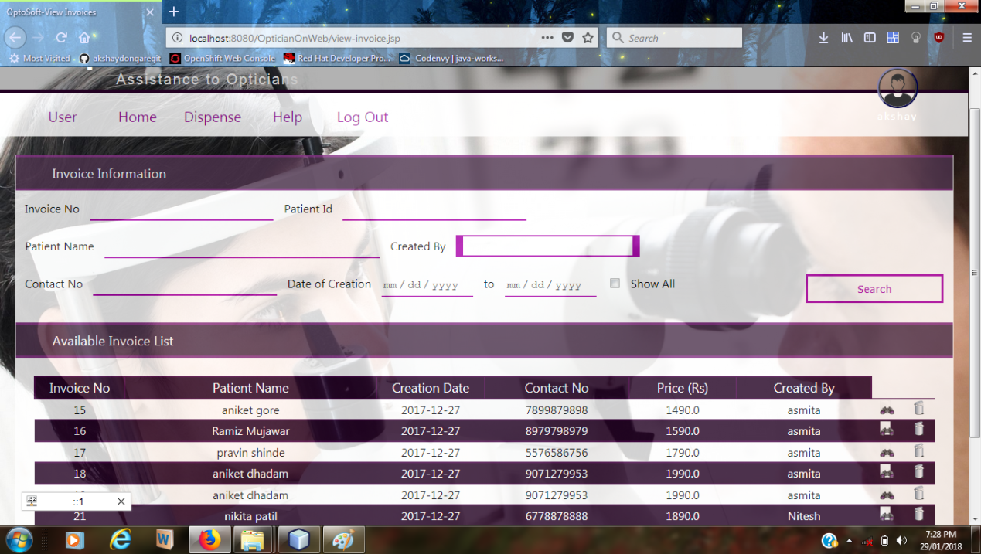

Invoice

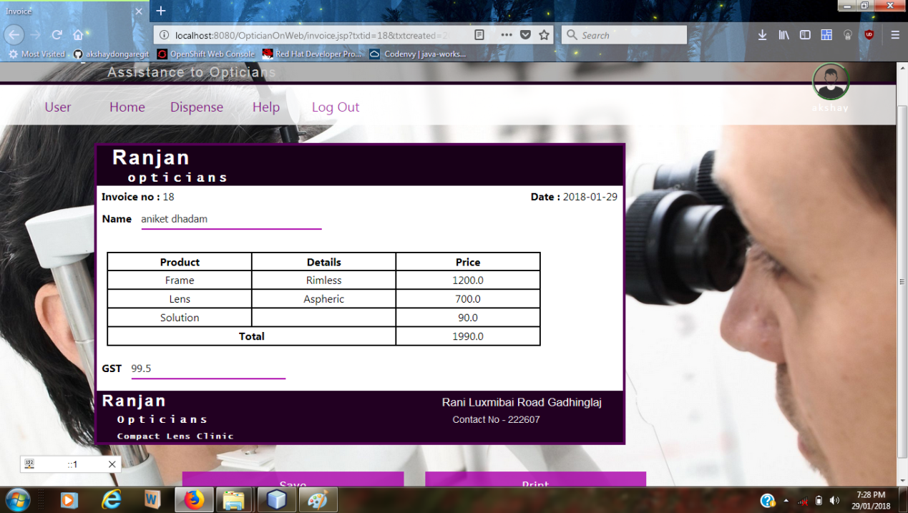

Find Invoice

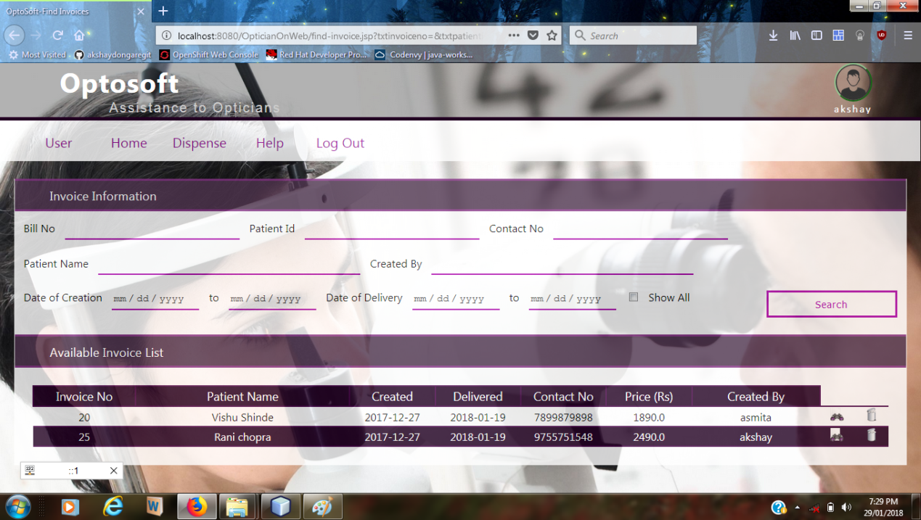

Dispense Report

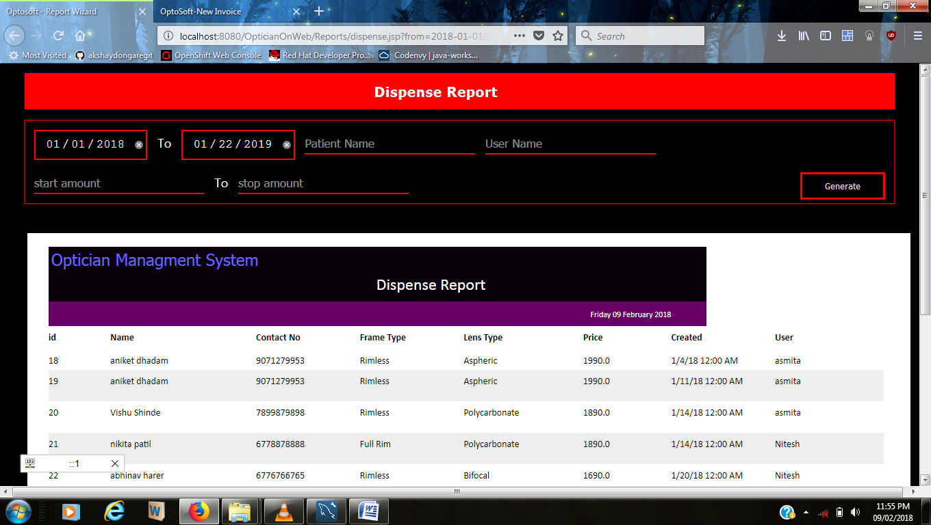

Authentication Error

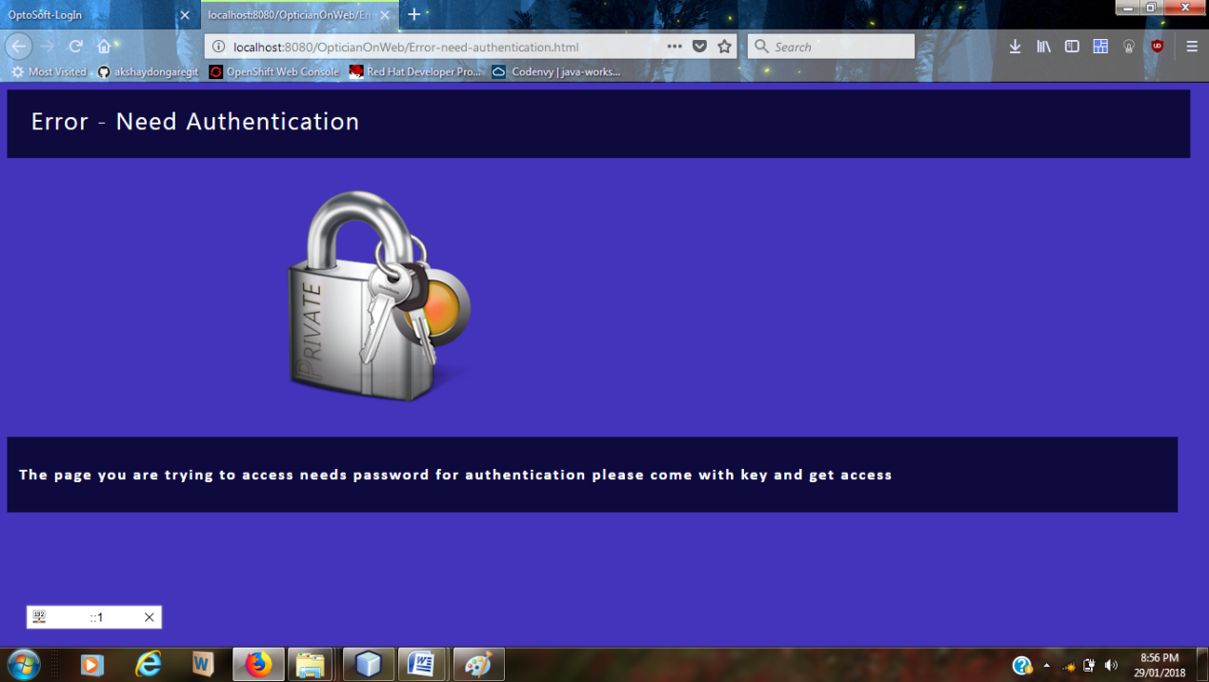

SOURCE CODE

home.jsp

<%@page contentType="text/html" pageEncoding="UTF-8"%>

<!DOCTYPE html>

<html>

<head>

<meta http-equiv="Content-Type" content="text/html; charset=UTF-8">

<title>Optosoft - Home</title>

<link rel="stylesheet" href="css/style.css">

<link rel="stylesheet" href="css/home.css">

</head>

<body>

<%@include file="master/user-selector.jsp" %>

<div class="header">

<h1 class="title"> Optosoft </h1>

<label class="title-tip"> Assistance to Opticians </label>

</div>

<div class="menu">

<nav class="navbar">

<ul>

<li> <a href = "user.jsp" > User </a> </li>

<li> <a href = "dispense.jsp" > Dispense </a> </li>

<li> <a href = "Reports/patient.jsp" > Reports </a> </li>

<li> <a href = "help.jsp" > Help </a> </li>

<li> <a href = "LogOut"> Log Out </a> </li>

</ul>

</nav>

</div>

<div class="body">

<a href="add-patient.jsp" class="link">

<div class="panel new-patient">

<img class = "panel-image" src="css/img/addusericon.png">

<div class= "panel-footer" > <h3> Add New Patient </h3> </div>

</div>

</a>

<a href="view-patient.jsp" class="link">

<div class="panel view-patient">

<div class="panel-body"> <img class = "panel-image" src="css/img/finduser1.png">

</div>

<div class= "panel-footer" > <h3> View Patient </h3> </div>

</div>

</a>

<a href="checkup.jsp" class="link">

<div class="panel checkup">

<div class="panel-body">

<img class = "panel-image" src="css/img/checkup.png">

</div>

<div class= "panel-footer" >

<h3> Patient Checkup </h3> </div>

</div>

</a>

<a href="find-patient.jsp" class="link">

<div class="panel find-patient">

<div class="panel-body">

<img class = "panel-image" src="css/img/finduser1.png">

</div>

<div class= "panel-footer" > <h3> Find Patient </h3> </div> </div>

</div>

</a>

</div>

<div class="footer">

</div>

<%@include file="master/userpanel.jsp" %>

<script type="text/javascript" src="js/form-common.js"></script>

</body>

</html>

<%-- Database connectivity--%>

<%@page import="java.sql.*" %>

<%

String SQL_DRIVER="com.mysql.jdbc.Driver";

String SQL_URL="jdbc:mysql://localhost:3306/optosoft";

Connection cn=null;

Statement st = null;

/*----------------------

connection to database

--------------------------*/

try

{

Class.forName(SQL_DRIVER);

cn=DriverManager.getConnection(SQL_URL,"root","rivendell");

//out.print("\n connection successfull ");

}catch(Exception e)

{

out.print("<script type=\"text/javascript\"> alert(\"Error occured while opening database "+e+"\"); </script>");

//out.println("Error occured while opening database : "+e);

}

//retriving username and password of current user

String username="",password="";

try

{

st=cn.createStatement();

String sql="select * from connected_users where session_id = '"+request.getSession(true).getId()+"'";

ResultSet rs = st.executeQuery(sql);

if(rs.next())

{

username = rs.getString("user_name");

password = rs.getString("user_password");

}else

{

out.print("<script type=\"text/javascript\"> alert(\"Oops! cant get user information \"); </script>");

}

}catch(Exception e)

{

out.print("<script type=\"text/javascript\"> alert(\"Oops! cant get user information \"); </script>");

}

%>

<%

java.util.Date tDate = new java.util.Date();

String today=""+new java.sql.Date(tDate.getTime());

%>

REPORT DESIGN

Date Wise Patient Report

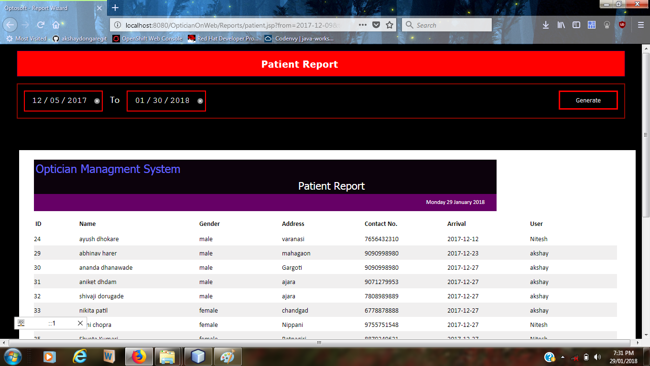

Date Wise Dispense Report

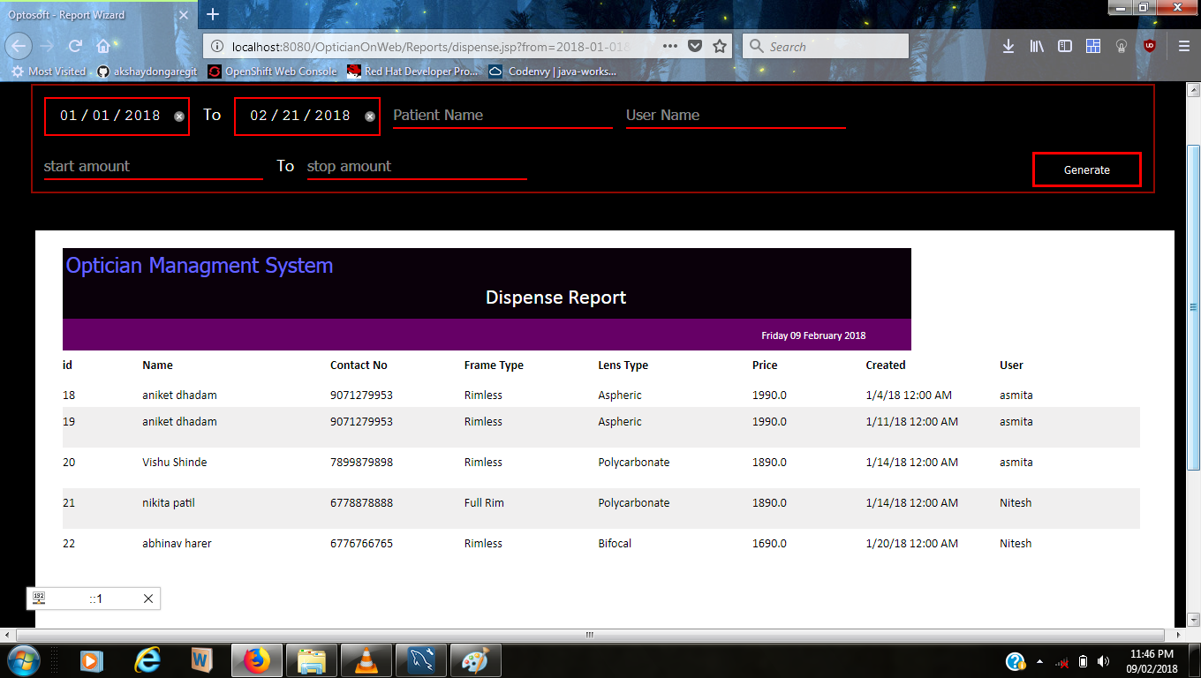

Dispense Report Name Wise

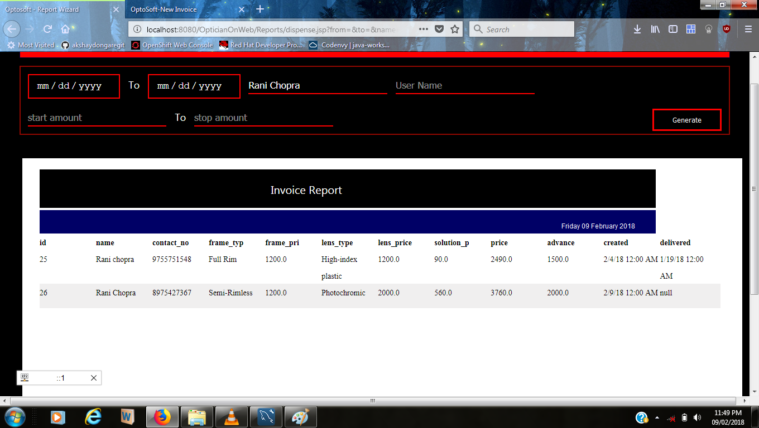

Dispense Report User Wise

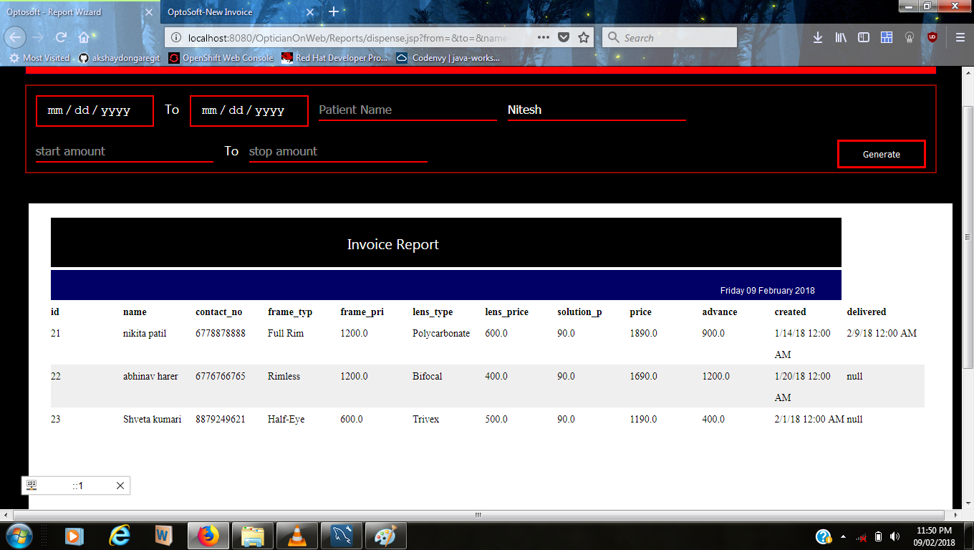

Dispense Report Price Wise

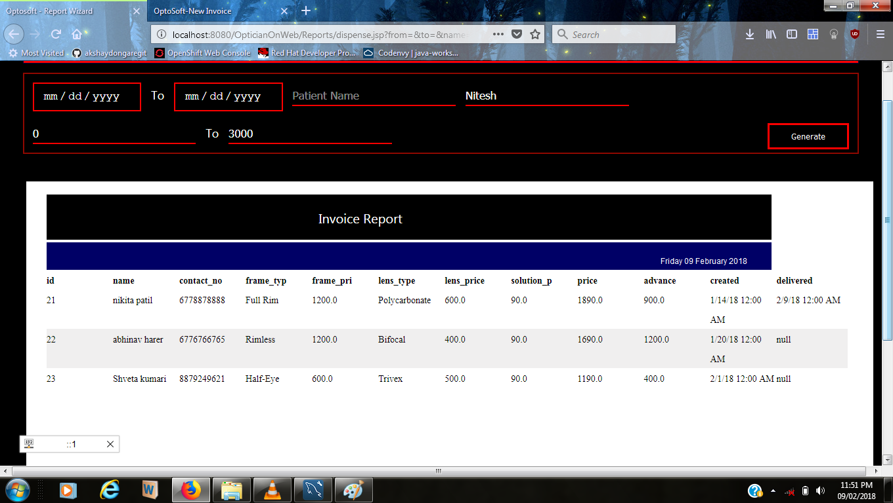

Simple Patient Report

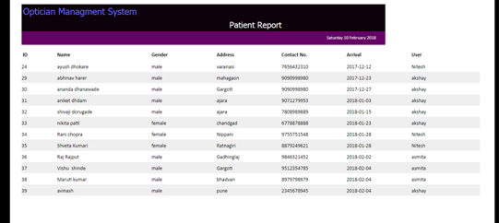

Simple Dispense Report

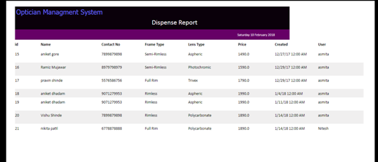

## Limitation

* Optician should have minimum (basic) knowledge about computer to handle the software.
* Optician should be trained for handling the system and interact with the various facilities provided in it.

**Conclusion**

This System has vast scope for modernization & to improve the exiting manual system.

* In this processing of information in much faster than manual system.
* This will eliminate redundancy of data.
* The tedious and time consuming job of calculating the bill as per requirement, maintaining all information about a particular Patient, finding various reports of various test, find previous reports and records for different register, can be done with computerized system in as small quantity of time.
* Human mistake, time consumption, time wastage, data processing time etc are reduce considerable by introduction computerized system implementing in the hospital.
* Due to computerization, a lot of tome is saved because all the paper work can be done on computer with greater accuracy.

Bibliography

**A Concise Introduction to Software Engineering**

_ *by Pankaj Jalote*

**JSP tutorial, JDBC tutorial , HTML tutorial , CSS tutorial**

*_ TutorialsPoint.com*

**JSP the complete reference**

*_ Phil Hanna*

**Smashing CSS**

*_ by Erec Meyer*

**JasperSoft Ultimate Guide**

**www.StackOverflow.com**

**www.W3Cschool.com**

**www.google.com**